
BEN CLOWARD – Character Animator & Technical Artist

PARTICLE REEL DESCRIPTION

All of the particle effects on my demo reel were created with the Vicious Engine particle effect editor with the limitations and memory requirements of the PS2 in mind.

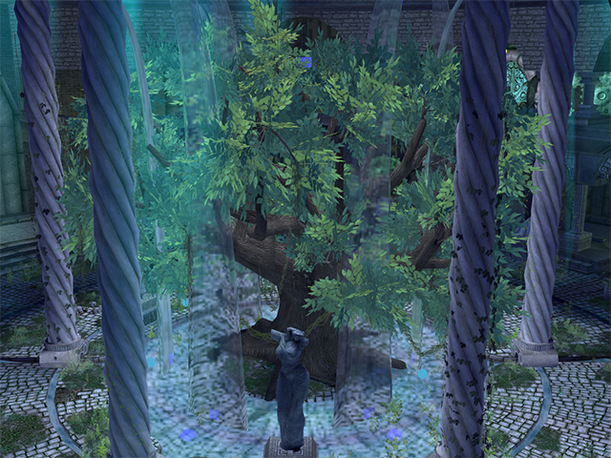
Atlantis Environment 00:06 - 00:53
The first 50 seconds of the reel exhibits particle effects that I created for the Atlantis environment. This was a game level designed to showcase the abilities of the Vicious Engine in order to market it to other game studios. In this environment I was in charge of creating all of the particle effects including mist, waterfalls, splashes, and fountains. We also created a particle museum room where we could show off the power of the particle editor. I created all of the particle effects in this room including explosions, a reactor core, thrusters, fireflies, etc. I did not model or texture the environment or the character.

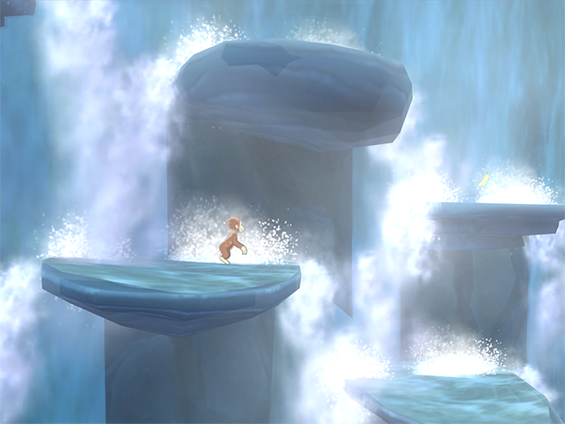
Curious George Waterfall Level 00:53 - 01:14
With about a week to go on the project, I was tasked with bringing the waterfall level of our Curious George game to life. I created flowing water, splashes, and mist to give the player the impression of navigating a giant waterfall. To achieve the effects, I used footage of real waterfalls. I tracked the movement of water from the top of the falls to the bottom in the video footage and turned the frames into animated textures that could be applied to the particle sprites. In order to fill the screen with hundreds of particles and stay within the memory and frame rate budget, I instanced the particle systems so that all of the copies required only the resources of a single effect.

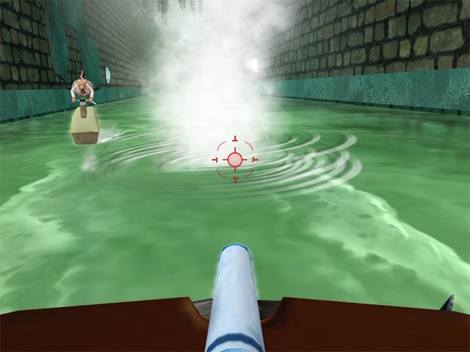
Flushed Away 01:14 - 01:29
In addition to rigging and animating a main character, I created a majority of the particle effects for Flushed Away. Since the game takes place in the sewers, I created many variations of splashes, ripples, water explosions, waterfalls, and boat wakes. To create the sprite texture for the ripples, I modeled a high poly version of a ripple, rendered the highlight side and the shadow side separately, and composited them together for the alpha channel. This created the appearance of a normal mapped ripple within the limitations of the PS2 hardware. I also created the appearance of the murky water with custom shaders in the game engine.

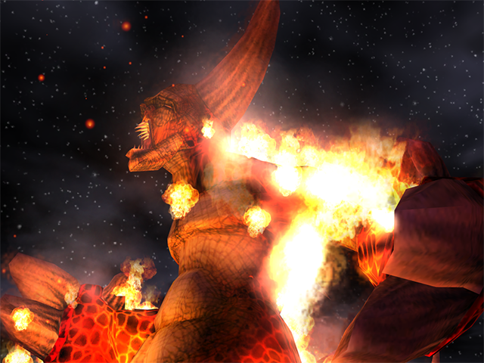
Fire Demon 01:30 - 01:46
This clip is from a game demo that our company made as part of a proposal for a potential project. I created the fire, embers, and heat haze in this shot. For the heat haze, I created a dUdV map with an alpha channel. Then I worked with the graphics programmer to make the haze refract the frame buffer, giving the impression that the heat from the fire was distorting the background behind it. I did not model, texture, rig, or animate the character in this shot. My contribution here was the particle effects.

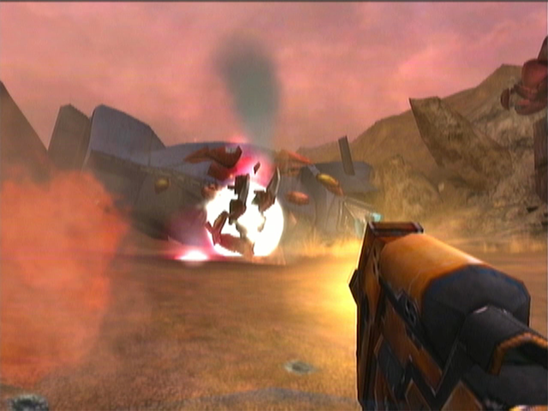
Robotech Invasion 01:46 - 2:12
I created a large percentage of the particle effects for Robotech Invasion including muzzle flashes, projectiles, explosions, thrusters, hit effects on various materials, etc. For this project I developed a system in which our game engine would spawn two effects when a projectile hit a surface – one for the projectile type and one for the surface type. This allowed us to achieve a large variety of hit effects on various surface types while keeping the overall number of effects low. I created all of the particle effects seen in these sequences – except the green blood coming from the enemies.

